Welcome to the new school year in Class 3.
Outlined below is a flavour of the exciting term ahead, as well as some essentials to help you get to know Class 3.
Writing
Roald Dahl’s writing can teach us so much to help our writing. The purpose of our trip to the Roald Dahl Museum was to understand how Roald Dahl found inspiration for crafting characters. Children will particularly explore how he developed beastly characters in his poetry, in order to inspire them to compose their own poems. Next, becoming Sentence Stars will be everyone’s aim, with perfectly punctuated sentences, as we write a recount and letters linked to our history topic .
Reading
You have probably already seen that our Class has an immense choice of books to enjoy, because reading is our most important activity. Your child will start The Reading Challenge and every day begins with ERIC time (every one reading in Class.)
Guided Reading
Practising comprehension, inference, summarising and predicting skills is the focus of Guided Reading, based around a quality book. which this term is a Roald Dahl one By the next lesson on the following Wednesday, your child needs to read a set number of pages, including some with an adult, to be prepared for the next guided discussion about the text.

Maths
The intention at the start of the year is to help everyone feel secure about Place value, as it is the basis of math’s success. As well as daily math’s fluency practice, learning Times Tables will play a big part, so that pupils are more quickly able to spot patterns that can help them in Maths.
History Topic: Battle of Britain
We will learn the significance of the Battle of Britain in WW2, as a turning point in history, exploring the causes of WW2 and impact of aircraft in Britain’s success .Learning will extend beyond the classroom with a visit to the Imperial War Museum RAF Hendon.
Science
This term there will be a focus on working scientifically through the topics of light and electricity. We will be looking at shadows and finding patterns in the way that their size changes and reflective surfaces, linked to WW2. After half term, we will explore simple circuits using cells, wires, bulbs, switches and buzzers.
RE
We will be looking at the significance of Baptism to Christians and reflect on how other religions celebrate key moments in life.

DT
We will make models of Spitfire planes that were used in the Battle of Britain.
Computing
On top of now being lucky enough to have a laptop per child, in addition every Monday your child will develop their ICT confidence with lessons led by a visiting Computing Teacher.
PE
PE kit must always be in school, with PE lessons on Monday and Wednesday, in which Invasion Games and dance will be the skills focus this term.
Modern Language
We will be learning Spanish greetings, numbers, the date, and classroom instructions, There will be a strong focus on conversation skills, developing accurate pronunciation.
Homework
Maths: Set Monday/return Monday
Literacy: Set Tuesday/return Monday
Guided Reading: Pages to read by the next Wednesday
We are very pleased your child is part of our Class and know they will quickly settle in, but if for any reason you have concerns you want to talk to us about, please fix a time, via the office, to see us after school, as it is too important to rush in the morning line !
With best wishes from,
Mrs Charter,Mrs Blumsom and Mrs Clarke.

.

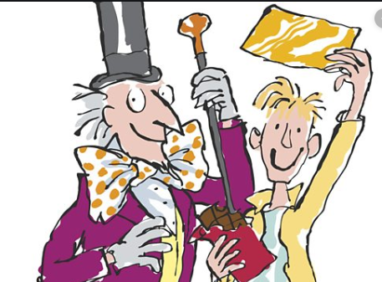
Class 3 Newsletter
Autumn 2019

