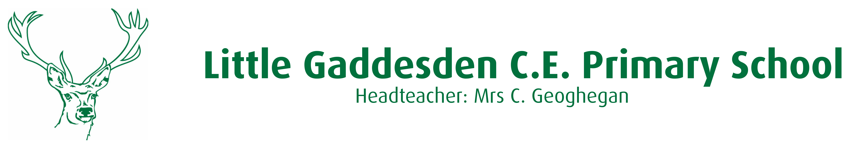
_______________________________________________________

Wednesday 23rd October 2019
Dear Parents,

Classes 1,2 & 3 – Elgiva Theatre, Cinderella – 18th December 2019
We have booked a trip to Elgiva Theatre, Chesham to see a performance of Cinderella. The children will travel by coach and will be back in school for 3.30pm.

All children will need to have a packed lunch on the day of the trip. In line with Universal Infant Free School Meals, the school kitchen will provide a packed lunch for all children in Classes 1 & 2. The lunch will contain a choice of roll, a piece of fruit, some crisps and a cookie, they will need to bring their own waterbottle. Children in Class 3 will need to bring in their own packed lunch.

Thank-you to the parents of the school who, together, make up The Friends and whose fundraising efforts have contributed to the cost of the coach enabling the cost per child to be limited to £14.00. Please pay for the trip and give your consent via your School Gateway account, you don’t then need to return the consent slip. Alternatively you can bring cash or a cheque into the Office with the signed slip below.
Please ensure you have given consent and made payment no later than Friday 15th November.
In order to meet the cost of the trip we would like a voluntary contribution of £14.00. Please give your consent and make payment for the trip via your School Gateway account.

Yours sincerely,

Charis Geoghegan
Headteacher
……………………………………………………………………………………………………………………………………………………………….....
Class 1,2 & 3 Trip to Cinderella – 18th December 2019

I give permission for ………………………………………………..to visit Elgiva Theatre and travel there by coach on Wednesday 18th December and enclose by voluntary contribution of £14.00 per child.

Child’s Name ……………………………………………………………………………………………………

Signed …………………………………………………………………………………………………………….. (Parent/Guardian)

