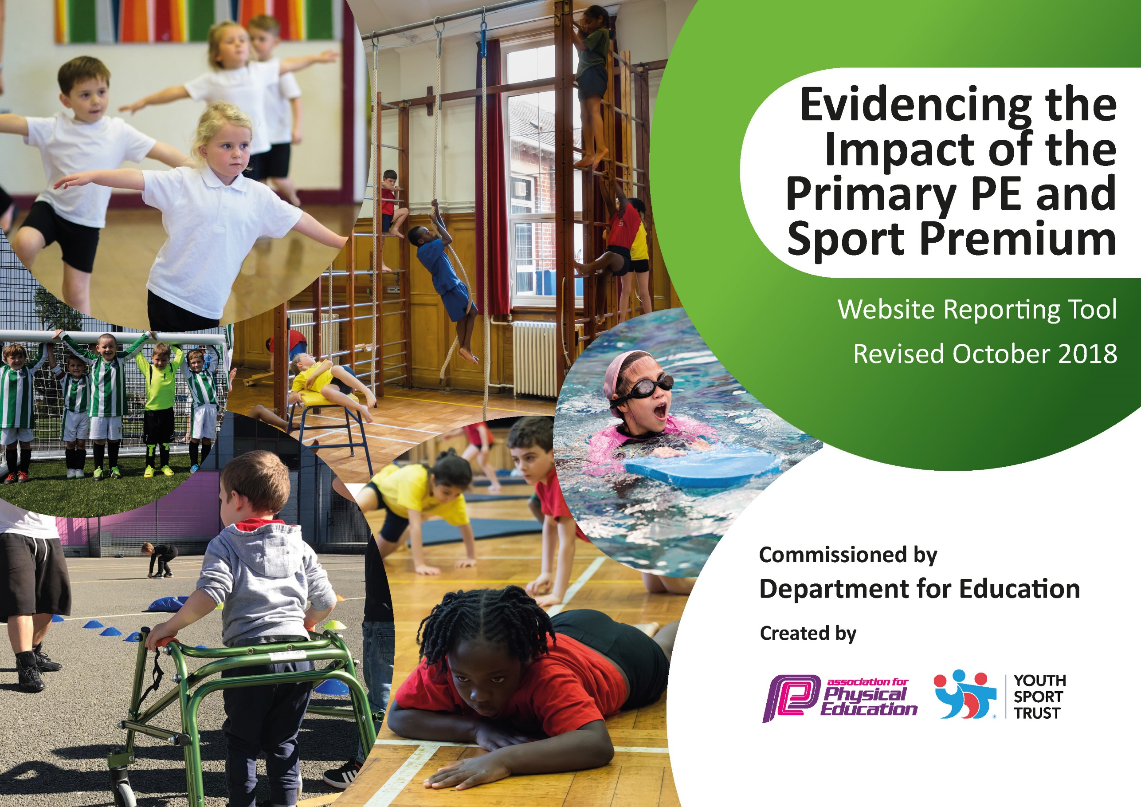
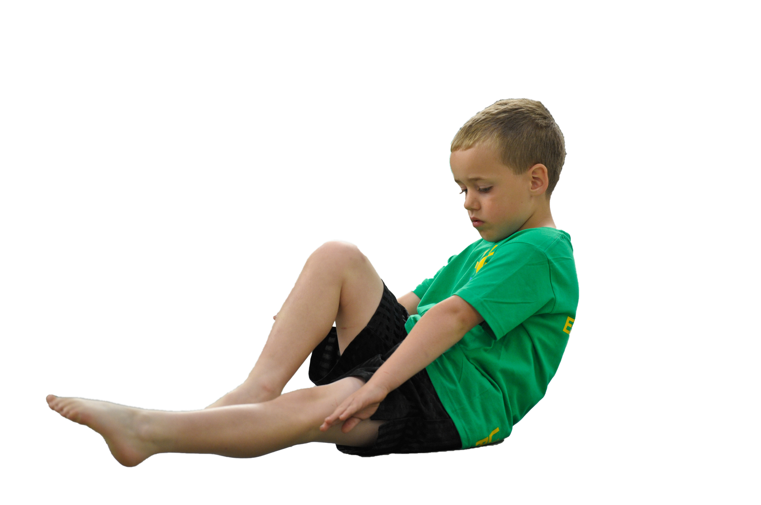
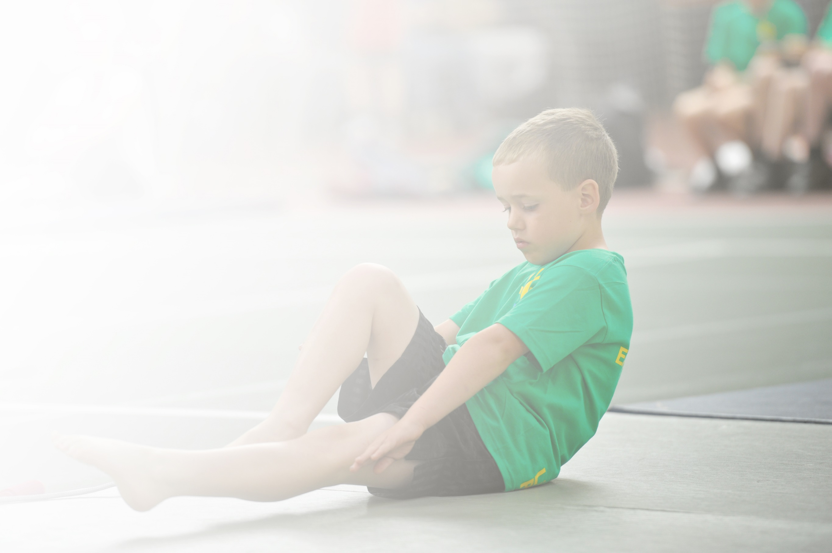
Schools must use the funding to make additional and sustainable improvements to the quality of Physical Education, Sport and Physical Activity (PESPA) they offer. This means that you should use the Primary PE and Sport Premium to:

- Develop or add to the PESPA activities that your school already offer
- Build capacity and capability within the school to ensure that improvements made now will benefit pupils joining the school in future years

Please visit gov.uk for the revised DfE guidance including the 5 key indicators across which schools should demonstrate an improvement. This document will help you to review your provision and to report
your spend. DfE encourages schools to use this template as an effective way of meeting the reporting requirements of the Primary PE and Sport Premium.

We recommend you start by reflecting on the impact of current provision and reviewing the previous
spend. Under the Ofsted Schools Inspection Framework, inspectors will assess how effectively leaders use the Primary PE and Sport Premium and measure its impact on outcomes for pupils, and how effectively governors hold them to account for this.

Schools are required to publish details of how they spend this funding as well as on the impact it has on pupils’ PE and sport participation and attainment by the end of the summer term or by 31 July 2019 at the
latest.
We recommend regularly updating the table and publishing it
on your website throughout the year, as evidence of your
ongoing review into how you are using the money to
secure maximum, sustainable impact. To see an
example of how to complete the table please
click HERE.

Support for review and reflection - considering the 5 key indicators from DfE, what development needs are a priority for your setting and your students now and why? Use the space below to reflect on previous spend, identify current need and priorities for the future.

Key achievements to date: | Areas for further improvement and baseline evidence of need:
- There has been a notable increase in the number of pupils participating in school sport. Monitoring of participation shows that 100% of KS2 pupils took part in a level 1 competition last year and 96% in a level 2 competition. 84% of pupils take part in an extra-curricular sports club at school. This has been achieved by funding the transport to sporting events to ensure they are open to all, funding targeted pupils to take part in clubs, extending the range of clubs and sporting opportunities available and by generally raising the profile of sport and PE.  - We have updated our PE curriculum resources and equipment to support the teaching and learning of PE. Monitoring of lessons and assessments shows that children are making good progress in PE. Any children who are not on track to make progress are highlighted and receive extra support. This has been particularly effective in EYFS & KS1 where we aim for all our pupils to have the fundamental movement skills they need by the end of KS1.  - The installation of our Daily Mile track in 2017 has meant that all children are engaged in regular physical activity. Alongside the Daily Mile the children achieve their 30 minutes of physical activity everyday through active playtimes and  - The PE Coordinator has achieved her Level 6 qualification in PE subject leadership and has helped less confident staff members with their planning and teaching in PE. Staff have received other training in areas of need identified by themselves (through courses provided by our sports partnerships) and we use carefully selected sports coaches to teach PE lessons alongside class teachers for CPD purpose.  - Our curriculum in PE is wide and varied with children getting to experience a wide range of opportunities as well as their regular curriculum PE lessons through regular enhancement days and a sports week in the summer term where new activities are introduced.  - We have built relationships with various local sports clubs to further enhance opportunities for our pupils. (e.g. we regularly work with Hemel Stags Rugby Club, LG tennis club, Berkhamsted Raiders FC, Hawks Lacrosse and others to provide lessons and clubs for the children.) | - To employ a PE Apprentice to support P.E. lessons enabling teachers to teach high quality lessons with support from another adult, to develop leadership skills in older children by supporting the Sports leaders and Bronze Ambassadors and to provide new clubs at lunchtime as a tool to raise self-esteem, confidence and improved behaviour among targeted groups of children.  - To further develop our outdoor space to enhance outdoor learning, with a focus on cross-curricular links to PE and physical activity. For example, link to outdoor learning in Science.  - To support new staff in the teaching of PE

Meeting national curriculum requirements for swimming and water safety | Please complete all of the below:
What percentage of your current Year 6 cohort swim competently, confidently and proficiently over a distance of at least 25 metres?  N.B. Even though your children may swim in another year please report on their attainment on leaving  primary school. | 100%
What percentage of your current Year 6 cohort use a range of strokes effectively [for example, front crawl, backstroke and breaststroke]? | 94%
What percentage of your current Year 6 cohort perform safe self-rescue in different water-based situations? | 94%
Schools can choose to use the Primary PE and Sport Premium to provide additional provision for swimming but this must be for activity over and above the national curriculum requirements. Have you used it in this way? | Yes/No

Action Plan and Budget Tracking
Capture your intended annual spend against the 5 key indicators. Clarify the success criteria and evidence of impact that you intend to measure to evaluate for students today and for the future.

Academic Year: 2018/19 | Total fund allocated: £16,878 | Date Updated: 06/09/19
Key indicator 1: The engagement of all pupils in regular physical activity – Chief Medical Officer guidelines recommend that primary school children undertake at least 30 minutes of physical activity a day in school |  |  |  | Percentage of total allocation:
 |  |  |  | 14%
School focus with clarity on intended impact on pupils: | Actions to achieve: | Funding allocated: | Evidence and impact: | Sustainability and suggested next steps:
Relaunch the ‘Daily Mile’ as The Golden Mile to ensure that all children are physically active for 30 minutes a day. This will take place in a new running club on 2 mornings a week as well as in school day.  Update and renew playground equipment so that more equipment is available for the children. MSAs upskilled to support play in the playground.  Work with targeted group of pupils so that they are educated for life about the importance of healthy eating and physical activity | Work with coach from premier sports to set up monitoring system for pupils to record their laps of our track and monitor their progress and achievements.  To ensure children have a good range of equipment to use in lesson and play time so that children enjoy their sports in school  Change 4 life club (Y6 sports leaders to help run this) | £1900  £200 | The two morning running sessions have on average 30 pupils attending each session. Y1 year group has most participants.  Teachers have said that this has noticeable impact on concentration.  Additional resources have led to increased activity at lunchtime  Sports Ambassadors are confident and have a high profile in the school. They have set up a lunchtime Rota, clubs, display board and led an assembly. | Use statistics from running club to encourage the less involved year groups to come along.  Use new PE Apprentice to run these clubs from next year to ensure consistency  Sports leaders to organise intra-school competitions.  Discuss with teachers new groups of children to be involved in Friday Fitness club
Key indicator 2: The profile of PESSPA being raised across the school as a tool for whole school improvement |  |  |  | Percentage of total allocation:
 |  |  |  | 4%
School focus with clarity on intended impact on pupils: | Actions to achieve: | Funding allocated: | Evidence and impact: | Sustainability and suggested next steps:
To develop resilience in pupils across the school to help them in both PE and generally in their attitudes to learning. | Children develop the skills of resilience, teamwork, mindfulness and an understanding of how keeping fit and healthy involves the mind and body. | Andy Mullin £395  Yoga £150  IW £131.40 | ‘Holistic PE week’ January 2019 (New Year, New You) to kick start this initiative.  IW to share knowledge on how to apply a holistic approach in PE lessons though individualised targets. | Introduce new clubs to help raise the self-esteem, confidence and behaviour of certain pupils e.g. Table tennis, Lego club. (from pupil voice)

Key indicator 3: Increased confidence, knowledge and skills of all staff in teaching PE and sport |  |  |  | Percentage of total allocation:
 |  |  |  | 40%
School focus with clarity on intended  impact on pupils: | Actions to achieve: | Funding  allocated: | Evidence and impact: | Sustainability and suggested  next steps:
To support members of staff in the teaching and assessment of PE so that pupils receive high quality PE lessons and are making good progress across the school. | PE leader to work with these members of staff to help plan and deliver PE lessons.  Identify any specific areas for development and find courses for them to attend.  Work alongside our PE coach and team teach some lessons.  Trainee teacher to undertake Level 5 P.E. subject leadership course | DSSN membership £522  YST membership £300  Game on coaching £3250.10  Gymnastics coach £1020  PE leader time  £902.65  IW Level 5 course £1,200 | Teachers and support staff have developed their confidence and knowledge of various activities and sports. –  LB attended dance course in Autumn term  Gymnastics coach supported staff throughout Spring term in curriculum lessons and with planning and assessments  IW has shared knowledge with other staff and led a staff meeting on PE on completion of her course | Continue to develop staff training needs as they arise
Key indicator 4: Broader experience of a range of sports and activities offered to all pupils |  |  |  | Percentage of total allocation:
 |  |  |  | 31%
School focus with clarity on intended  impact on pupils: | Actions to achieve: | Funding  allocated: | Evidence and impact: | Sustainability and suggested  next steps:
Survey pupils to find out new sporting interests that we can target in enhancement days, extra-curricular clubs and sports week.  Link our PE provision to exciting events happening in the sporting world e.g. the women’s World Cup and the Cricket world cup (Summer 2019)  Sports week – June 2019  Whole school trip to Phasels wood for OAA activities  Enhance outdoor learning for EYFS with ‘School in the woods’  Pupil survey showed children interested in tag rugby | New archery club started in the Autumn term.  KS2 children have half a term of volleyball.  Bollywood dancing workshop  Wisemoves drama and dance  Berkhamsted Raiders to provide coaching for girl’s football (summer term)  Premier sports coaches to provide different activities for sports week m  Membership of National Trust so we can use the forest for Class 1  Unit of tag rugby coaching for junior age classes and invest in equipment for competitions | New equipment: £668.02  £138  £286  £395  £1645.20  £95  £1620 | Children have benefitted from a range of activities and sports. They have broadened their experience and skillset e.g. maypole dancing, indoor athletics  Pupil voice showed this was very popular and has encouraged some girls to join the school football club.  Very positive feedback from pupils, staff and parents after this visit  Class 1 go to the forest every Tuesday afternoon for school in the woods.  Class 3 & 4 took part in tag rugby tournaments | Organise two enrichment days – pupil voice  Extra lunchtime clubs
Key indicator 5: Increased participation in competitive sport |  |  |  | Percentage of total allocation:
 |  |  |  | 14%
School focus with clarity on intended  impact on pupils: | Actions to achieve: | Funding  allocated: | Evidence and impact: | Sustainability and suggested  next steps:
Make sure all opportunities are inclusive and open to all  Partnerships with local sports networks and secondary schools (DSSN & Tring) | Pay for transport to sporting competitions and taster days | £1600  DSSN £522  Tring £50 | The school entered 14 competitions. In total, 100% of children in Class 1 and 2 participated in at least one competition and 96% of children in Class 3 and 4 | Continue with inter and intrasports opportunities.
TOTAL: £15,970.55

