Things to remember:
- Bring your book bag and a water bottle every day
- Send your child with his/her P.E. kit on a Monday please.
- If your child is being collected by someone different to our normal arrangements, please sign the form inside the classroom door.
- Please make sure all your child’s belongings are labelled
- For weekly planning and other information concerning Class 1, please check the noticeboard just inside the gate.

Forthcoming events:
- Whole School Assembly-Our Vision- Friday 31st January
- Feeling Good Week Monday 10th February
- Hands on session- Maths Wednesday 12th February 2.30pm
- Half term Monday 17th February to Friday 21st February
- Science Week- week beginning 2nd March
- Parental Consultations Thursday 5th March
- Mothering Sunday Assembly- Friday 20th March
- Easter Service –Friday 3rd April
- School finishes for Easter Friday 3rd April at 1.30pm

Welcome to
Little Gaddesden
Primary School!
“….curious and creative thinkers, independent and enthusiastic
learners and confident individuals…”
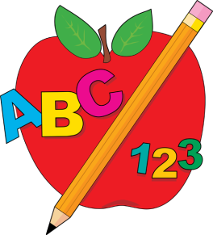
Spring Term 2020
Class 1-Reception
Class 1
If you have concerns or questions please see a member of the Reception team at the beginning or end of the day.
This term we will be learning……….
Literacy
Last term, we covered all the alphabet phonemes (sounds). We will now move onto two graphemes (letters) making one phoneme like ch, th, oo etc We aim to cover 2 sounds and a common exception word (tricky word) each week, these will be sent home with the children for you to reinforce. Using the Sounds-Write programme, your child will start to read and write cursively, working towards sentences and stories!
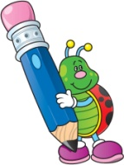
Reading
The children will be accessing guided reading sessions and some individual reading. They will also be encouraged to take a reading book daily. Please share this book EVERY day and write in their reading record. Thank you.

Mathematics
In Maths this term, Class 1 will be moving on to manipulating numbers up to 20 and investigating place value as well as exploring shape, space and measures including naming and discussing 2 and 3D shapes, capacity and length.
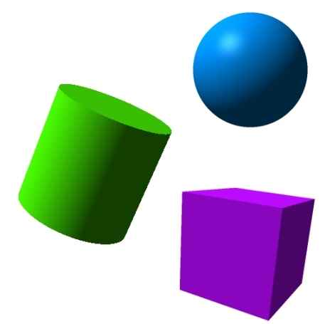

Topic
For this half term, we will be learning about ‘Transport and Journeys’ following on from feedback on the evaluation sheets.
