______________________________________________________
27th February 2020
Dear Parents,

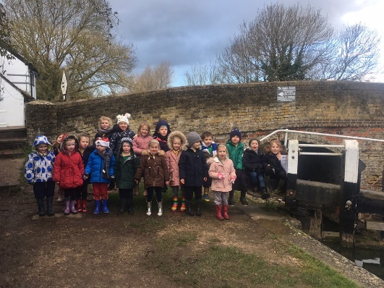
We hope you all enjoyed a relaxing half-term - we have already had a very busy week back in school. On Tuesday the children enjoyed a pancake breakfast, thank-you to Mrs Steeds for organising. In the afternoon, children in Year One took part in a sports competition with other local schools at Berkhamsted leisure centre. The children had a very enjoyable afternoon. On Wednesday morning it was lovely to see so many parents taking part in Class Three’s Maths workshop.
Yesterday, Class One went to Marsworth Reservoir to look at the boats as part of their topic on ‘Transport and Journeys’. Despite the cold, they all had lots of fun. Just before half-term, I joined Class Two on a trip to Greenwich to the National Maritime Museum which was a fantastic day.

Letters
Victorian Classroom Workshop – Class Three

SATs Meeting
Just a reminder that Mrs Patel will be holding a SATs meeting tomorrow (Friday) at 8.30am for all parents of children in Year Six. We hope to see you all there.

Book Week
This week has been ‘Book Week’ in school. Thank-you to the Arts Ambassadors for all the activities they have organised. The children have been doing lots of reading and finding out about different books. Thank-you to all of you who entered photos for the’ Extreme Reading Challenge’. The winners are: Class One – Sophia Fogden; Class Two – Will Rochester; Class Three – Charlie Rainbow and Class Four – Josh Collins.
The travelling Book Fair has been here this week. You can still visit today after school or on Friday before school.

Science Week Challenge (to be completed at home)
Next week is Science week and Miss Allen has organised lots of fun and exciting activities for the children. As part of Science week, children can take part in the ‘Create-A-Tree’ challenge at home.
The Challenge: ‘Create’ a Tree using 4 sheets of plain or coloured A4 paper only (from your recycling box). Use only scissors and engineering skills to create your trees. No glue, sticky tape, staples or paper clips to be used.
All trees to be brought into school for Monday 9th March for judging. There will be a small rpize for the best tree from each class.

Parent Consultations
Just a reminder that parent consultations will take place next Wednesday and Thursday. There are still some parents who haven’t booked an appointment. Please do this online as per the letter sent out. If you have any difficulties, please contact the Office.

Sports Relief – A Message from the Sports Leaders
On Friday 13th March, the pupils of Little Gaddesden School will be able to come to school wearing sports kit for a £1.00 donation for Sports relief. During School, the pupils will take part in activities to raise money. Classes 2,3 and 4 will do a 2-minute skipping challenge with the person who does the most in each class receiving a prize. Class 1 will do a hula-hooping challenge with a prize for the person who can keep going for the longest. We will be selling Sports Relief wristbands from Monday 9th March, they cost £1.00 each

Class 4 Blog
http://littlegaddesden.edublogs.org/2020/02/03/vote-for-your-next-class-book/

Please see below for a message from the Friends

Yours sincerely

Charis Geoghegan
Headteacher

Message from the Friends

Film Night - Friday 28th Feb
We are showing The Smurfs. Please either pay and fill out consent details on School Gateway or hand in form/payment to one of the committee members. Pick up time is 5pm (unless your child is going to Beavers)

Leap Year Ball - Saturday 29th Feb
2 more sleeps!!!
Start time: 7pm
Carriages: 1am
Bring with you: tickets, cash for games, masks, dancing shoes!

Dani, Claire, Jane, Hannah and Mark

