______________________________________________________
12th March 2020
Dear Parents,

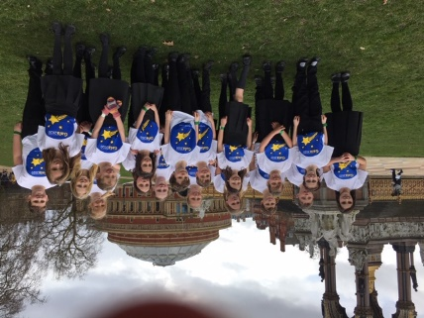
We had a wonderful day at the Albert Hall last Sunday for the Hertfordshire Schools’ Singing Gala. The children performed beautifully and found it very exciting to be performing on stage - we were so fortunate to be sitting right at the front!

Letters
Class One – Trip to Bekonscot
Selected children in Class 2 & 3 – Hockey tournament at Tring School

Coronavirus
Public Health England and Hertfordshire County Council are in touch with schools on a daily basis about the coronavirus. At the moment, they are advising that the risk to children and others is low. This is a changing situation and it is possible that guidance may change. If things do change, we may need to contact parents and carers quickly, please ensure that the school have your most up to date contact details.
Should you or your children experience any of the symptoms, you should phone the NHS on 111 or Public Health England on 0300 3038537 (option 1) and they will advise you what to do. The Department for Education have also set up a coronavirus helpline – 0800 0468687. Public Health England have issued advice on the coronavirus for places of education, which can be accessed via the following link: www.gov.uk/government/publications/guidance-to-educational-settings-about-covid-19

If you or any member of your family is diagnosed with the virus or, has been advised to self-isolate following contact with someone who has tested positive, please inform the school so that we can take guidance.

Data Collection Sheets (Record of the details, including contact details, we hold for your child)
Thank-you to those of you who checked, signed and returned the data collection sheets for your child. These were either given out at parent consultation meetings or sent home with Class 4. If you haven’t yet returned your form, please could you do so as soon as possible so that we can ensure we have the most up to date details for all children.

Class Two – Pirates day – Wednesday 18th March
Just a reminder that Class 2 will be having a Pirates Day next Wednesday. Could all the children come dressed as a pirate – but please leave the swords and cutlasses at home! Thank-you.

Mothers’ Day Assembly
On Friday 20th March we are having an assembly to celebrate Mothering Sunday at 9.05am in the Hall. All are welcome.

Sports Relief
Just a reminder that as tomorrow is Sports Relief, children can come to school dressed in sports kit (something that they will be comfortable in all day), in return for a £1.00 donation. The Sports Leaders have organised some ‘sporty’ challenges for the children during the day.

Cake Sale – Friday 13th March
Phoebe, Matthew, Ben and Molly from Class 4 have organised a cake sale, which will take place after school tomorrow to raise funds for the RSPCA and Blue Cross The cakes will cost between 50p and £1.50. If anyone wanted to contribute some cakes the children would be very grateful.
Last week Amelie, Daisy, Eirys, Tabi and Molly raised £81.05 from their cake sale for ‘Paint the Town Red’. Thank you to all of you who supported them.

PGL Second payment
For all parents in Class 4, the second payment for the PGL trip in June of £125 is due by Friday 3rd April. Please pay for this via your School Gateway account. Alternatively you can bring a cheque or cash into the Office. If you would like to pay for this in smaller amounts, please let the Office know.

Reminders
Class 3 – consent and payment for the Victorian Classroom workshop was due on Wednesday 11th March. Please could we ask parents that haven’t done so yet, to make payment as soon as possible.
Dinner money for this half of term is due this week, on Friday 13th March.

Class 4 Blog
http://littlegaddesden.edublogs.org/2020/02/03/vote-for-your-next-class-book/

Yours sincerely

Charis Geoghegan
Headteacher

