______________________________________________________
5th March 2020
Dear Parents,

We have had a busy few weeks. Science week has been really exciting; with several visitors and lots of opportunities for children to be experimental and discover information for themselves. A big thank-you to Miss Allen for all her organisation.

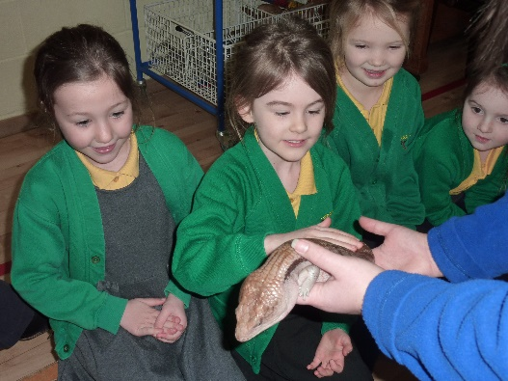
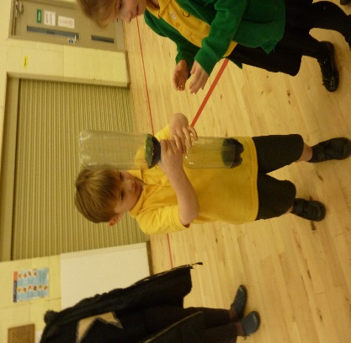

It has been lovely to see many of you in school for Parent Consultations. We will let Class 4 parents know early next week about a revised date to meet with Mrs Patel.

Letters
Dinner Money Letters – Dinner money for this half of term is due by Friday 13th March
RAH Singing Gala – final details for selected parents

Parents Coming into School – new procedure
We are very lucky at Little Gaddesden that we have so many parents who volunteer their time to help in school in various ways. From next week, to ensure we are complying with our Safeguarding procedures we would ask that parents don’t use the door from the playground to enter the school either in the morning or the afternoon, but rather go to the front door and ring the bell. This is to ensure that we know at all times which adults are in the building, to help keep the children and all the information we hold in school safe. The children are very capable of sorting out their own bags and coats and staff are always on hand to help so there shouldn’t be any need for you to come in with your children. Obviously the teachers are happy to talk with parents so please contact the Office who will arrange a mutually convenient time for you to meet with your child’s teacher.
Please could we also remind parents that under no circumstances should mobile phones be used for anything within the school.

A reminder: Science Week Challenge (to be completed at home)
Don’t forget, Monday is the deadline to bring in your trees as part of the ‘Create-A-Tree’ challenge.
The Challenge: ‘Create’ a Tree using 4 sheets of plain or coloured A4 paper only (from your recycling box). Use only scissors and engineering skills to create your trees. No glue, sticky tape, staples or paper clips to be used.

Coronavirus
We understand that some of you may be concerned about the Coronavirus and how this will impact your children in School. The School is receiving daily updates from Hertfordshire’s Director of Public Health and from the Department for Education. As the situation changes, so does the advice and guidance, but please be assured that we are following any advice given. Current national guidance is that schools do not close unless, following a suspected case of COVID-19 they are advised to do so by Public Health England.
The Department for Education have launched a helpline to answer questions about COVID-19 related to education. Staff, parents and young people can contact the helpline via 0800 0468687 (Monday-Friday 8am-6pm) or via email; DfE.coronavirushelpline@education.gov.uk. The following links may also be useful for parents:
https://www.gov.uk/coronavirus
https://www.gov.uk/government/publications/guidance-to-educational-settings-about-covid-19

As the guidance states that personal hygiene is one of the most important ways we can tackle the virus, staff have been talking to the children about the importance of effective hand-washing and ensuring that children are properly washing their hands.

Cake Sale
Amelie, Daisy, Eirys, Tabi and Molly from Class 4 have organised a cake sale to take place tomorrow after school either in the playground or hall, depending on the weather. Cakes will cost between 50p and £1.50. After reading about the charity ‘Paint the Town Red’ which funds medical detection dogs, in First News in class, the children wanted to raise money for this good cause.

Class 4 Blog
http://littlegaddesden.edublogs.org/2020/02/03/vote-for-your-next-class-book/

Please see below for a message from the Friends

Yours sincerely

Charis Geoghegan
Headteacher

Message from the Friends

We are delighted to announce that, together, we raised an incredible £15,000 from our Leap Year Ball which was held at Ashridge on Saturday night. We are absolutely thrilled and wanted to send out a huge thank you to all who attended and we hope you had as fantastic an evening as we did! We look forward to hearing how the school want to spend the money! Thank you also to Emma and James from The Club London who helped us to make the Ball such a success.

