LITTLE GADDESDEN CHURCH OF ENGLAND PRIMARY SCHOOL

ADMISSIONS POLICY FOR 2021/2022

The governors of Little Gaddesden Church of England Primary School will admit 15 children, whose birthdays fall between 1st September 2016 and 31st August 2017 inclusive, into the Reception class, from the beginning of the Autumn Term 2021.

As far as possible, the school will ensure that pupils with disabilities have access to the same opportunities as other pupils. The school does not have any specific units or facilities for pupils with particular special needs, and there are no specific facilities for pupils with physical disabilities. One classroom is located upstairs; two downstairs classrooms may be entered without steps; one downstairs classroom has a single step. There is level access at the main school entrances.

The governing body is required to abide by the maximum limits for classes with children from Reception, Year 1 & Year 2 (i.e. no more than 30 pupils per class).

Children with statements of special educational needs or an Education Health and Care (EHC) plan naming the school are not subject to the oversubscription criteria. The school will admit all children whose statements or EHC name the school.

The school co-operates with the Hertfordshire Fair Access Protocol for children who are hard to place. These children will be given priority over children on the waiting list and may be admitted even if the school is full.

In the event of there being a greater demand for admission than there are places available, the following criteria will be applied in the order set out below:-

- ‘Looked after’ children, and children who were previously ‘looked after’ but immediately thereafter became subject to an adoption, child arrangement or special guardianship order.
The Children’s Act 1989 defines a child who is ‘looked after’ as a child or young person who is accommodated by the local authority (Section 20), or a child or young person who is the subject of a full care order (Section 31) or interim care order (Section 38). An ‘adoption order’ is an order under Section 46 of the Adoption and Children Act 2002. A ‘child arrangement order’ is an order setting out the arrangements to be made as to the person with whom the child is to live, under Section 14 of the Children and Families Act 2014. Section 14A of the Children Act 1989 defines a ‘special guardianship order’ as an order appointing one or more individuals to be the child’s special guardian (or special guardians).

2) Children resident in the Parish of Little Gaddesden and adjoining areas outlined on the accompanying map, measured in accordance with Hertfordshire County Council’s measurement system, with children closest to the school given priority. If this category is oversubscribed priority will be given as follows:
a) sibling in the school at the time of admission;
b) geographic proximity, measured in accordance with Hertfordshire County Council’’s measurement system, with children closest to the school given priority.

3) Children with siblings in the school at the time of admission.

4) Children not resident within the Parish of Little Gaddesden or adjoining areas outlined on the map, but whose parent(s)/guardian(s) have attended services in Little Gaddesden Parish Church at least once a month during the previous two years. (A letter verifying the required level of attendance will be sought from the parish priest.) Applicants in this category should also complete the Supplementary Information Form.

5) Any other children.

Hertfordshire County Council Measurement System

A ‘straight line’ measurement system is used in all home to school distance measurements. Distances are measured using a computerised mapping system to two decimal places. The measurement is taken from the AddressBase Premium address point of your child’s house to the address point of the school. AddressBase Premium data is a nationally recognised method of identifying the location of schools and individual residences.

Tie Break

If there are two identical addresses of separate applicants, the tie break will be random. Every child entered onto the Hertfordshire County Council’s admissions database has an individual random number assisgned, between 1 and 1,000,000, against each preference school. Where there is a need for a final tie break, the random number is used to allocate the place, with the lowest number given priority.

Twins and Multiple Births

Where the last available place is offered to a twin or multiple birth, then the other twin or sibling(s) will be offered places as exceptions to the infant class size rule.

Home Address

The address provided must be the child’s current permanent at the time of application. ‘At the time of application’ means the closing date for applications. ‘Permanent’ means that the child has lived at that address for at least a year and/or the family own the property or have a tenancy agreement for a minimum of 12 months.

The application can only be processed using one address. If a child lives at more than one address (for example, due to a separation), the address used will be the one which the child lives at for the majority of the time. If the child lives at two addresses equally, the address of the parent/carer who claims Child Benefit /Tax Credit will be considered as the child’s main residence. If a family is not in receipt of Child Benefit /Tax Credit, alternative documentation will be requested. If a child’s residence is in dispute, parents/carers should provide court documentation to evidence the address that should be used for admission allocation purposes. If two different applications are received for the same child from the same address (for example, containing different preferences), the application from the parent in receipt of child benefit will be processed if the applications cannot be reconciled.

Siblings

‘Sibling’ refers to brother or sister, half brother or sister, adopted brother or sister, child of the parent/carer or partner, children ‘looked after’ or previously ‘looked after’. This does not include children temporarily living in the same house (for example, a ‘looked after’ child in a short term or bridging placement). In every case, the sibling must be living permanently in the same family home as part of the family household, at least from Monday to Friday. The sibling must be in the school at the time of the application and be likely to remain in the school at the proposed date of admission.

Deferred Admission and Summer-born Children

Parents offered a place may defer the date of their child’s admission until later in the year, but not beyond the point at which the child reaches compulsory school age, and not beyond the beginning of the final term of the school year for which it was made.

Where parents of a ‘summer-born’ child (April 1 ‒ August 31) wish the child to start school in the autumn term following their fifth birthday, the governors will consider the request. If parents do not take up the offered place before the end of the academic year of entry, then they would have to re-apply for a place in Year 1. Parents should discuss this with the school as soon as possible and this would be treated as an in-year application.

However, if parents wish such a child to be educated ‘out of year group’ (i.e. in the Reception Year rather than Year 1) they may request this and should discuss it with the school as soon as possible. Such applications will be considered by the governors on a case-by-case basis. Each case will be judged on its individual merits, but admittance to an out-of-year group would require exceptional and extenuating circumstances, with professional evidence explaining why the child’s needs cannot be met in the chronological year group. A new application would need to be made in the normal admissions round for Reception in the year they wish their child to join, and this application will be considered alongside all other applications. Parents do not have the right of appeal against a decision not to accept this request.

The school provides for the admission of all successful applicants who have reached their fourth birthday by the end of August 2021. Please note that these arrangements do not apply to any Nursery intake: parents of Nursery children must reapply for a place in Reception. Nursery attendance does not guarantee a place in Reception.

Older Children and In-Year Applications

Applications to admit older children may be made to the school at any time. The school is part of Herts County Council’s co-ordinated system for In-Year applications. Parents should make an application online at www.hertfordshire.gov.uk/inyear. In-Year applications will be considered in accordance with the oversubscription criteria outlined in this document. The county council will write to you with the outcome of your application and, if you have been unsuccessful, will include registration details to enable you to log in and appeal online at www.hertfordshire.gov.uk/schoolappeals.

Admissions Procedure for the Reception class

- Parents/carers must complete the Local Authority Common Application Form for their home area. The online address is www.hertfordshire.gov.uk/admissions.
- The school’s Supplementary Information Form should also be completed by those whose applications come under Category 4 of the admissions criteria.
- Applications must be received by January 15, 2021.
- The governors will determine the allocation of places for the 2021/22 school year, in accordance with the Admissions Policy. Allocations will be emailed or posted to parents on April 16, 2021. Parents must respond to offers by April 28, 2021. Those who applied online should respond online; others should return the response form direct to the Admissions and Transport Team at County Hall.
- Appeals: Parents/carers who have not been allocated a place for their child in the Reception class have the right of appeal to an independent panel. Parents who applied online should log into their online application and click on the link register an appeal. Out-of-county residents and paper applicants should contact the Customer Service Centre on 0300 123 4043 to request their registration details and log into www.hertfordshire.gov.uk/schoolappeals, clicking on the link ‘log into the appeals system ‘. (For In-Year applications, parents wishing to appeal should contact the school directly in the first instance.)
- Waiting List: If there are more applications than available places, the governors will maintain a continuing interest list. Late applications will go onto this list in a position determined by the criteria. Parents/carers must inform the governors if they wish their child’s name to be on the list. They are requested to inform the governors if they wish their child’s name to be removed. If a place becomes available in the school, it will be offered to the child who best meets the published admission rules. Parents are required to reapply for places at the end of every school year, through the Hertfordshire County Council co-ordinated scheme..

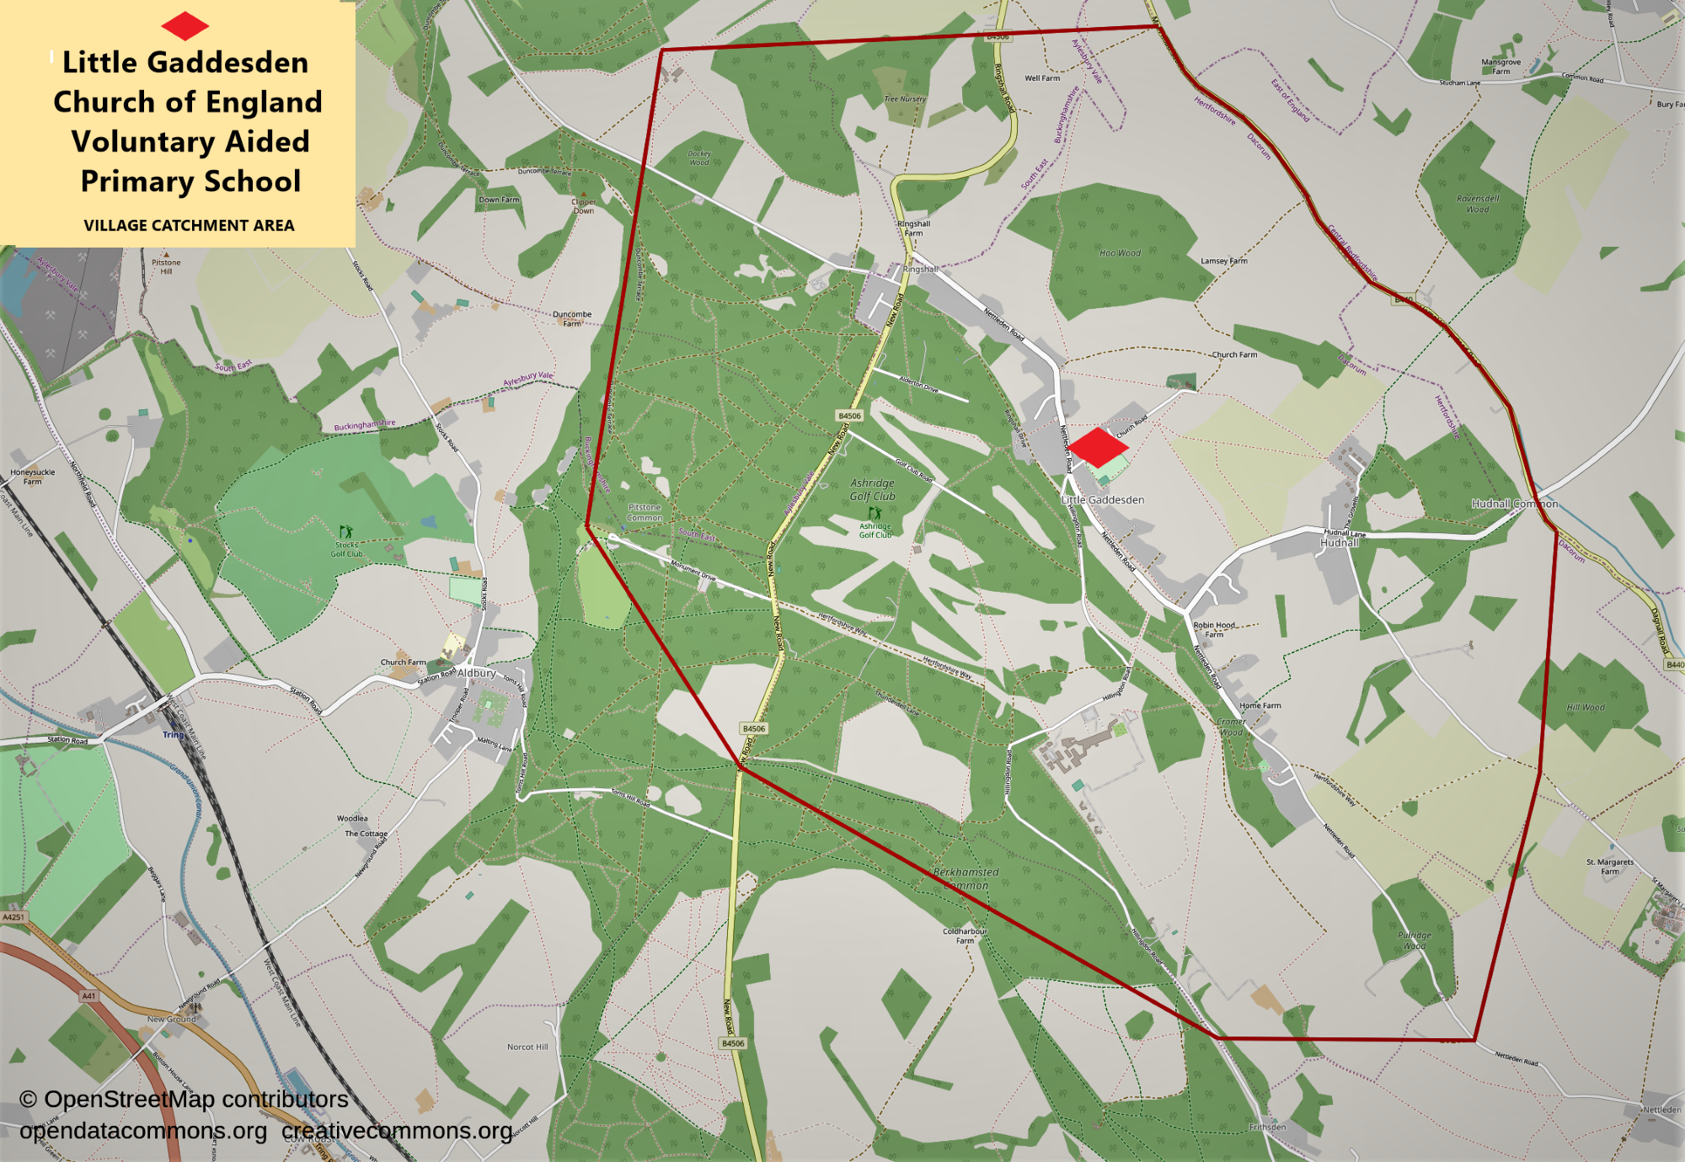
LITTLE GADDESDEN CHURCH OF ENGLAND PRIMARY SCHOOl

SUPPLEMENTARY INFORMATION FORM
FOR SEPTEMBER 2021

Please return this form to the school.

CHILD'S SURNAME

CHILD'S FORENAMES IN FULL

DATE OF BIRTH …………………………………….

FULL POSTAL ADDRESS

………………………………………………………………Postcode

TELEPHONE

Home…………..

Mobile

E-MAIL.....................................................................................................................

NAMES OF PARENTS/GUARDIANS

………………………………………………………………………………………………

If you do not live in the Parish of Little Gaddesden,
have you attended Little Gaddesden Parish Church
at least once a month during the last two years?

Date ……………………………………….

Signed ………………………………………………………………….

If you are not successful in gaining a place at Little Gaddesden School, your child can be placed on our “continuing interest” list. Please contact the school office if you would like us to do this.

