Welcome back,

I hope you had a great summer and are looking forward to the new term. We have lots to look forward to and I plan to make sure your children feel both motivated, enthused and challenged in their learning throughout the year.
Equipment:
In Class 4, the children are encouraged to have their own writing equipment in a small pencil case. Blue gel or ink pens only please and a coloured biro for editing. They also need pencils and highlighters. Coloured pencils and pens are useful, but we do have a good stock of these in class.

As always, the children are encouraged to bring a re-useable water bottle to keep them hydrated and help their concentration. As we are enjoying the prolonged summer weather this is especially important!
The children will have PE twice a week (Wednesday and Thursday) but should always have their labelled PE kit in school. It is important that they have the correct clothing and are responsible for it.
Homework:
The children will receive a minimum of Spelling and Maths homework every week. This will be staggered at the beginning to ease the children back in. Weekly homework tasks will be set on Monday and tested the following Friday. Homework Club is TBC.
In order to prepare your children for secondary school. many of the expectations and additional responsibilities they are given in Class 4 are designed to promote organisation and independence.

If you have any concerns or worries please come and speak to me or another member of staff.

Mrs Patel

Autumn Term Overview

Maths: Our main focus this term is to develop a sound understanding of Number
through problem solving and reasoning. Reasoning is a critical skill that we develop to help children to make sense of concepts in Maths. We achieve this by using mathematical ‘super powers’: conjecturing and convincing; specialising and generalising; organising and classifying and imagining and expressing. This term’s topics include: number and place value; written and mental methods across all four operations, fractions and algebra. Ask your child about the Rock Star Times Table challenge!
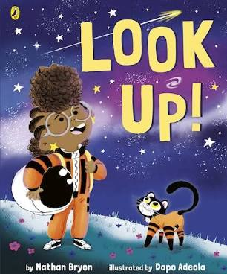
English: We will begin the term with a whole school class read: ‘Look Up!’ by Nathan Bryon. It is about a girl who dreams of going to space just like her Hero: Mae Jemison – The first African American astronaut. This will inspire children to write a biography about this inspiring woman.

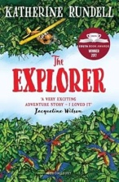
Our second book of the term will be ‘The Explorer’ by Katherine Rundell. Class 4 will have the opportunity to write their own explorer’s guide to The Americas. This will include explanations on how to survive the most extreme terrains: from odious oceans and perishing poles to violent volcanoes… We will then end the topic with a narrative description of life in the Amazon.

*It is worth noting that there will be a heavy focus on Grammar, Spelling and Comprehension throughout the year to support Year 6 in the lead up to SAT’s.

Reading: Although many of the children are confident readers, it is important that they continue to develop their skills of reading, understanding and questioning. An hourly-guided whole class reading session will take place once a week alongside focused guided group discussions. During this time children will read an age appropriate book and be expected to answer questions and uncover meaning such as the author’s motives.

The children will be expected to have a free-choice reading book. Please support your child by checking that they are reading every day, including to an adult for a minimum of twenty minutes. Ask your child about our ‘space reading challenge’ and our ‘100 book challenge’

Science: Our first topic is ‘Forces’. The topic covers: gravity, friction, water resistance and air resistance.

Art and Design: In response to our Amazing Americas topic, we will be exploring South American Art.

RE – This term’s topic is ‘Beliefs and Practices’. Children will be given the opportunity to describe, make connections and reflect on some religious beliefs and practices including how celebrations are marked such as Diwali.

Geography: This term’s topic is the Amazing Americas. Pupil’s will build upon their current knowledge and understanding of local geography by crossing the Atlantic Ocean to North and South America.

PE: The children will be taught by a sports coach on Wednesdays and Thursdays. For this term they will be take part in Dance and Invasion Games (netball and handball). There may be sporting opportunities through the term and I will pass on details as they arise

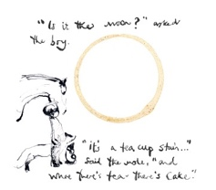
PSHCE: Our theme is ‘Think Positive’. We will have regular assemblies to support this and exploring how to recognise and manage our feelings in a healthy way in class. Current topics and areas that call for understanding will be covered as they arise.

MFL: This term we are learning French. This will mainly involve speaking and listening and writing basic words and phrases.

Music: Class 4 will be listening to and ‘getting creative’ with Classical Music.

Computing: This term Class 4 will be taught all about e-safety and how to stay safe when using technology.

Class 4
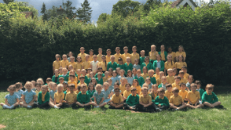

“…curious and creative thinkers, independent and enthusiastic learners and confident individuals…”

