Things to remember:
- Bring your book bag and a water bottle every day
- Send your child with his/her P.E. kit on a Monday, leave it on their peg and we’ll send the children home in it on a Thursday.
- If your child is being collected by someone different to our normal arrangements, please sign the form inside the classroom door.
- Please make sure all your child’s belongings are labelled
- For weekly planning and other information concerning Class 1, please check the noticeboard just inside the gate.

Forthcoming events:
- Animal Workshop Wednesday 21st April
- BMX Mike in to school Tuesday 27th April
- Bank Holiday Monday 3rd May
- A Life Workshop Thursday 6th May
- Christian Aid Week –week beg 10th May
- INSET Friday 28th May
- Half term 31st May – 6th June
- Visiting athlete Thursday 10th June
- Book Fair –week beg 14th June
- Visiting poet Thursday 17th June
- Circus workshop-Thursday 1st July
- Sports Day-Wednesday 14th July
- Friday 21st July –end of term- finish at 1.30pm

Little Gaddesden
Primary School
“….curious and creative thinkers, independent and enthusiastic
learners and confident individuals…”
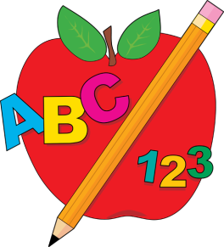
Summer Term 2021
Class 1-Reception
Class 1
We had such a great time learning last term and we’ve really enjoyed our Forest Schools adventures, which will continue this term
(Tuesday afternoons)
If you have concerns or questions please see a member of the Reception team at the beginning or end of the day.
This term we will be learning……….
Literacy
Last term, we covered all the two and three letter graphemes (letters) that make one phoneme(sound) like er, ou, oo igh air etc. We will be moving on to same digraph, different spelling (ay/ai) and split digraphs and will revise and use all our sounds and common exception words (tricky words) in some extended writing involving simple punctuation. Using the Sounds-Write programme, your child will continue to write cursively, working towards sentences and stories!
Reading
The children will continue with Guided Reading sessions on a weekly basis where we read as a group and discuss what we’ve read. They will also be reading individually to an adult. They are given a new reading book on Monday, Wednesday and Friday, please share this book every day and write in their reading record. Thank you.
Mathematics
In Maths this term, Class 1 will be continuing to manipulating numbers up to 20 and beyond, calculating with addition and subtraction, sharing, doubling and problem solving! As well as this we will be exploring shape, space and measures including 2 and 3D shapes, positional language, capacity, weight, and length.
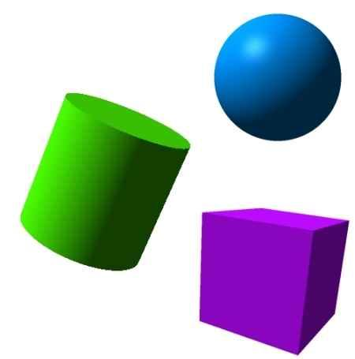
Topic
Lots of our children were interested in learning more about how we travel so our new topic is Transport where we hope to organise a trip on a public bus and a day out to Bekonscot model village!

